Ontology-Based Student Modelling

Desislava Paneva
Institute of Mathematics and Informatics, BAS, Bulgaria
8, Acad. G. Bonchev str., Sofia
dessi@cc.bas.bg

Abstract
The student model is a key component in any eLearning system with respect to providing adaptive learning content and personalized instructional flow/s. However, the process of development and accurate representation of the learner’s information, knowledge, and behaviour, as well as the mechanisms for tracking the continuous changes in the learner’s characteristics, is made more difficult in contemporary eLearning systems. To help getting over this difficulty, this paper describes a Semantic web structure for representing a student model. The structure is based on multiple student data with respect to the most important and well-developed learner model standards. The second section of the paper considers the main components of this model, which are separated into two main parts: general student information and information about student behaviour in the learning domain. The third section outlines how the model can be realized via the Semantic web technologies and in particular by student ontology. The final section discusses how Semantic web-driven solutions can complete the development of innovative eLearning system.

Keywords
Student modelling, Semantic web, Ontology

- INTRODUCTION
The software developers face a number of challenges and difficulties when trying to model student profile and activities on real eLearning systems. The process of collecting student modelling data is time-consuming and requires the development of complex data structures to represent student’s personal information, knowledge and behaviour in the learning domain. Once student data is collected, it must be converted into a format compatible with knowledge representation and reasoning systems to function as the input for the adaptive systems. Faced with these requirements, student modelling data is often stored in proprietary, hard-to-access formats that don’t encourage reuse or distribution. In addition, in most cases the student models can only be used with the learning application, which it was developed for and when the application is changed or replaced they will be useless.
Recently, student modelling researchers have begun to adopt technologies, applications and standards from the Semantic Web to solve the problems mentioned above. The first ideas of using ontologies for learner modelling have been reported by Chen&Mizoguchi [1]. Kay also argues about the use of ontologies for reusable and “scrutable” student models [2]. More recently the idea of using sharable data structures containing user’s features and preferences was proposed in order to enable personalized interactions with different devices for the benefit of the users. For this purpose, a user modelling mark-up language for ubiquitous computing built on XML technology has been proposed as a platform for communication [3].
In the ELENA project (http://www.elena-project.org/) there is a very rich and detailed learner model developed. It is distributed and reflects features taken from several standards for a learner modelling and in particular, IEEE LTSC’s Personal and Private Information (PAPI) standard and IMS Learner Information Package (LIP). Its features can be combined according to the requirements of specific personalization techniques, which are provided as personalization services in a P2P learning network RDF and RDFS as key tools of the semantic web, which are used to handle such situations [4]. However, this model cannot cope with the user inputs at different levels of detail, precision and completeness. Using RDF and RDFS to develop the student ontology is a good solution, but it is more appropriate to do that via Web Ontology Language because of its rich functionality, actuality, tool support and status as an official W3C recommendation.
In this paper we present a different vision for the presentation of a student model. We outline how it can be realized via the semantic web technologies. This model is based on much more student data than models created until now, considering the most important and well-developed learner model standards and including some specific extensions. We follow the idea that the student models developed with the Web Ontology Language (OWL) have the advantages of formal semantics, easy reuse, easy portability, availability of effective design tools, and automatic serialization into a format compatible with popular logical inference engines.

- Main elements of the student model
Building a student model involves defining: the "who", or the degree of specialization in defining who is modelled, and what the learner history is; the "what", or the goals, plans, attitudes, capabilities, knowledge, and beliefs of the learner; the "how" the model is to be acquired and maintained; and the "why", including to whether to elicit information from the learner, to give assistance to the learner, to provide feedback to the learner, or to interpret learner behaviour. These interpretations of the student model do not have to be considered isolated from the developed standards and specifications in this area because our goal is to maximize the reusability and portability of the designed student model. We examined two of the most important and well-developed standards - the PAPI standard [5] and the IMS LIP standard [6]. Both standards deal with several categories for information about a learner. These standards have been developed from different points of view. The PAPI standard reflects ideas from intelligent tutoring systems where the performance information is considered as the most important information about a learner. The PAPI standard also stresses on the importance of inter-personal relationships. On the other hand the LIP standard is based on the classical notion of a CV and inter-personal relationships are not considered at all.
After we found these specifics of the standards, we decided to take them into consideration, to combine some of their parts and to add some specific extensions, too.
From our point of view the student model needs to cover a certain amount of information that can be divided into two main groups:
- general student information such as learning goals, cognitive aptitudes, measures for motivation state, preferences about the presentation method, factual and historic data (personal information), etc.,
- information about student’s behaviour in the learning domain such as overall competence level for the course, module competence level, concept competence level, module study time, test solving status, etc.
Naturally, student models “do not have to fully account for all aspects of student behaviour. In fact, we are interested in computational utility rather than in cognitive fidelity” [7].

General Student Information
Learning goals answer the questions of why the student uses the educational system and what the student actually wants to achieve. Learning goals are crucial for establishing the correct teaching strategies, as they represent some basic features of a particular learning process.
Motivation state is the force that drives the learner to be engaged in learning activities. The student motivational state can be measured by a number of long-term and short-term parameters such as motivation, effort, attention, interest, distraction, persistence, etc. These parameters are in turn associated with other factors including knowledge level, readiness, complexity of topic, learning outcome, etc. In our model we choose the student’s interest and knowledge level as motivation factors.
Both last education and experience information can be used as bases for deriving student model parameters. Last education includes a description of the qualifications, certifications and various licenses of a learner. Experience information is about the student previous experience that may have an impact on student learning achievement, such as relevant work experience, perspectives, occupation, information about how familiar the student is with the learning environment, etc. This background information is helpful when selecting appropriate pedagogical strategies and adaptive navigation methods.
The students may have different preferences over a range of aspects of an education system. These preferences could be domain-related or domain-independent. The students have to inform the system directly or indirectly about their preferences. It is important for a web-based educational system to present and organise the learning materials in the student's preferred way. The most important part of student preferences is the learning style that is correlated with multiple intelligence in terms of Gardner’s theory. Howard Gardner’s most current research defines eight distinct intelligence forms stated as follows [8]: verbal/linguistic intelligence, logical/mathematical intelligence, visual/spatial intelligence, musical/rhythmic intelligence, bodily/kinaesthetic intelligence, intra-personal intelligence, interpersonal intelligence, naturalist intelligence. Gardner suggested that everyone possesses all above intelligence but in varying degrees, consequently one person can show low ability in one domain area but high ability in another domain. According to the multiple intelligence theory, intelligent educational system should be individualised so that every student can be guided to achieve his or her maximum potential [9].
A learning style is defined as the unique collection of individual skills and preferences that affect how a student perceives, gathers, and process learning materials [10]. If the learning materials are presented in the way that best fits the learning style and multiple intelligence of an individual student, the student can learn better and faster, and consequently resulting in creativity increasing and academic achievement.
A student model may contain a number of factual and historic data about an individual student such as name, age, ID, postal address, e-mail, telephone, etc. These are necessary for initialising an individual student model.

Information about Student’s Behaviour
Sison and Shimura [11] use the term “student behaviour" to refer to a student’s observable response to a particular stimulus in a given domain. This, together with the stimulus, serves as the input to a student modelling system. This input (i.e., the student behaviour) can be an action (e.g., solving a test) or, more commonly, the result of that action (for example the test solution). It can also include intermediate results (e.g., scratch work) and verbal protocols. In intelligent tutoring systems, stimuli from the tutor would typically come in the form of selected questions or problems about a particular topic, module and course.
Observing the student behaviour in the learning domain we can classify the following indicators: concept competence levels, module competence levels, overall competence levels for the course, test solving status and module study time.
For the first three indicators the competence levels are determined according to the user’s answers to selected questions or problems regarding a particular concept, module or course.
A student can have one of the following two "concept competence levels":
- Not-mastered - the concept has not been mastered by the student,
- Mastered - the concept has been mastered (if a concept is mastered, all of its prerequisite concepts are mastered).
A student can have one of the following five "module competence levels":
- Not-ready - the module is not ready to be learned yet because necessary prerequisite is not meet by the student,
- Ready - the module is ready to be learned because the student has studied all of its prerequisites,
- Visited - the module or one or more of its sub-modules have been visited by the student for a short period of time (set by teacher at authoring time),
- Learned - the module has been studied for certain amount of time or all of its sub-modules are learned or mastered by the student,
- Mastered - the content of this module has been mastered by the student.
A student can have one of the following three overall competence levels for the course:
- Beginning - the student is a beginner to this subject domain,
- Intermediate - the student has some basic knowledge of this subject domain,
- Advanced - the student has advanced knowledge of this subject domain.
A student can have one of following five "test solving status":
- Learned - the module has been studied for certain amount of time or all of its sub-modules are learned or mastered by the student,
- Unsolved - the student has not tried to answer the test,
- Unsolved-but-studied-hint - the student has studied the hint of questions in the test, but has not tried to answer these questions,
- Solved - the student has answered the test’s question correctly without studying hint,
- Solved-with-help-of-hint - the student has answered the test’s questions correctly with the help of hint,
- Failed-or-studied-solution - the student provided the incorrect answer to the test, or the student studied the solution before answering the test’s questions.

- student ontology
It is not immediately obvious how to construct an effective student model using existing web ontology languages – OIL, DAML+OIL, RDF/RDFS, OWL, etc. We decided to use OWL DL [12] as our ontology language because of its functionality, tool support (in particular, the Protégé 3.0 development tool) and status as an official W3C recommendation. In terms of the general structure of our student model ontology, we decided to separate the ontologies into two main parts: general student information and information about the student’s behaviour in the learning domain. We use the classification included in part 2 as base concepts of the modelled ontology. The classes’ taxonomy is the following:

General student information
- StudentPersonalData - StudentName, StudentSurname, StudentAge, StudentPostalAddress, StudentEmail, StudentTelefone,
- StudentPreference - StudentMultipleIntelligence, StudentLearningStyle, StudentPhysicalLimitation, StudentLanguagePreference,
- StudentBackground - StudentLastEducation, StudentExperience,
- StudentMotivationState - StudentInterest, StudentKnowledgeLevel,
- StudentLearningGoal.

Information about the student’s behaviour in the learning domain
- ConceptCompetenceLevel
- ModuleCompetenceLevel,
- CourseCompetenceLevel,
- ModuleStudyTime,
- TestSolvingStatus.

To provide the relationships between two individuals from given classes, we define the relevant OWL object properties that are in the following form: hasA and isAOf, where A is the name of some class or sub-class (for example, hasStudentBackground, hasStudentExperience, isStudentKnowledgeLevelOf, etc.). The two forms determine inverse properties i.e. if some property links individual p to individual q then its inverse property will link individual q to individual p. For example, hasStudentLearningGoal and isStudentLearningGoalOf are inverse properties. Every property has a domain and a range specified. The property links individuals from the domain to individuals from the range. For example, the property hasStudentLearningGoal has the domain Student and the range StudentLearningGoal.
Figure 1 depicts the internal structure of the ontological classes and a part of their properties.

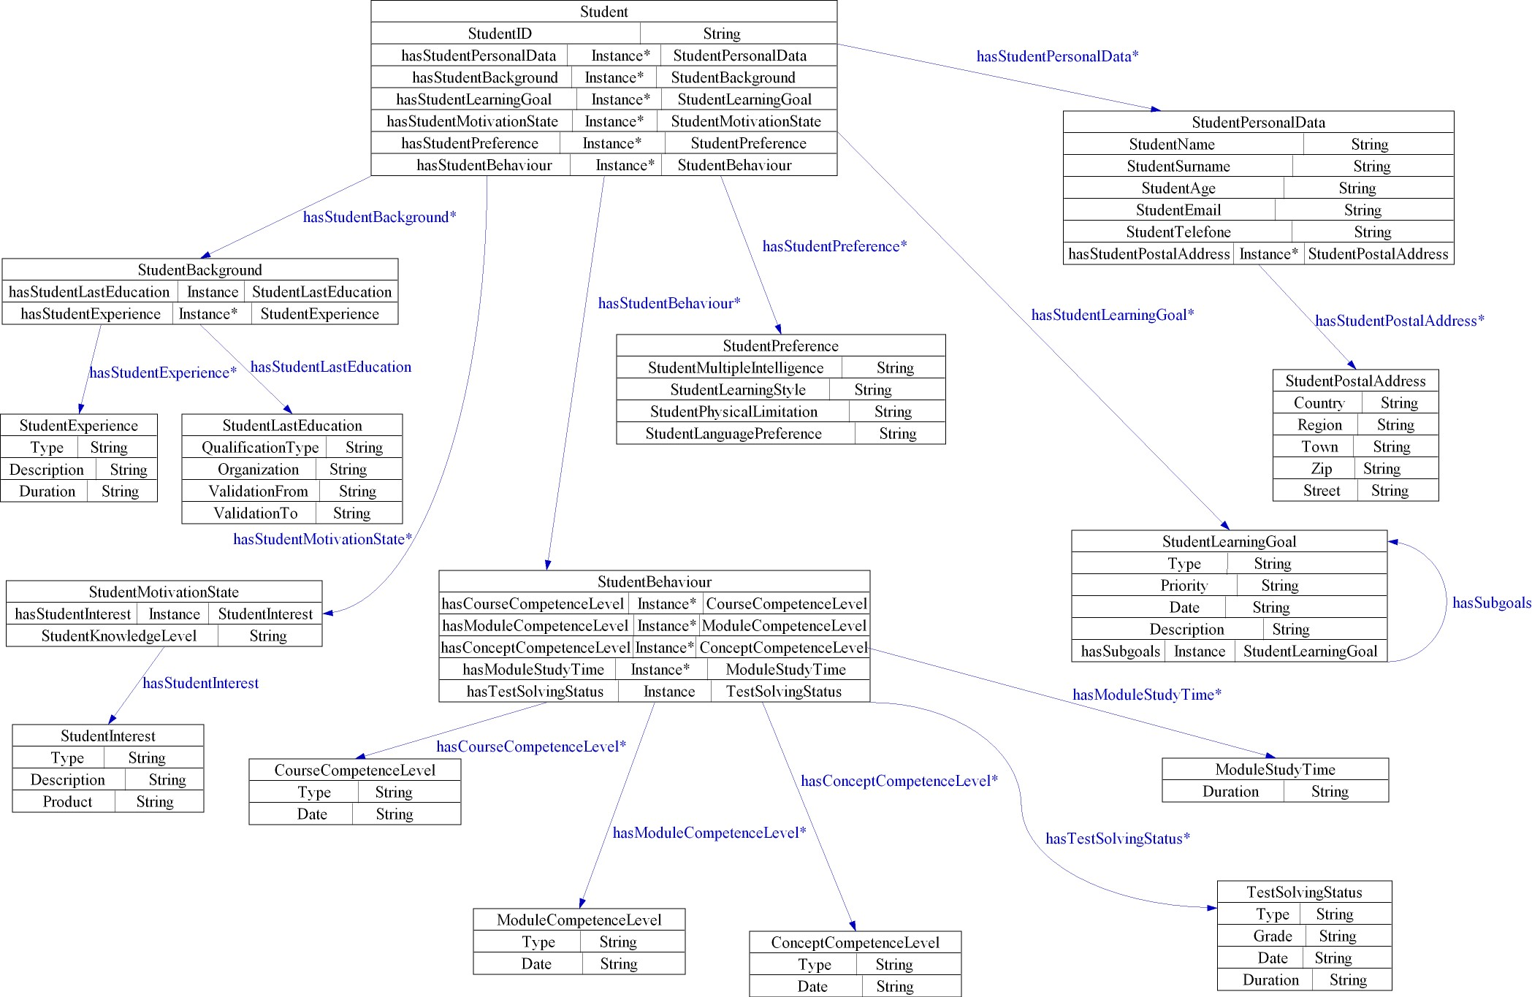

Fig. 1. Student ontology

In OWL, the properties are used to create restrictions. In our student ontology we use quantifier restrictions that are composed of a quantifier, a property, and a filler. The two quantifiers that we use are the existential quantifier () and the universal quantifier (). For example “ hasStudentMotivationState StudentMotivationState” is made up of the existential qualifier () the property hasStudentMotivationState and the filler StudentMotivationState. We add some qualifier restrictions to sub-classes in the student ontology. They inherit the restrictions of their super-classes.
The ontology, which has been created, does not pretend to be fully comprehensive. To describe the object domain (student model) in detail, we have chosen only concepts, which can be matched to individuals easily and in a straightforward way. By joining the general student information and the information about student’s behaviour in the learning domain, a student modelling application is better able to react to changes in student's type and behaviour during the learning process, which often happens in a long-time practice.
In maintaining the student model it has to be considered that the student:
- does not perform consistently,
- forgets information randomly,
- demonstrates large leaps in understanding.
In a next phase the student ontology has to be mapped to the domain ontology. Ontology-based student modelling requires a referential structure, which in a learning context needs to evolve according to the user’s progress in learning, according to his goal, domains of interest, which need to be acquired and updated (concepts like Interests, Goals). A part of the general student information is dynamically changeable and is based on the achieved learning goal of the student and the review of his updated abilities. The information about the student’s behaviour in the learning domain is naturally changeable, too and can be traced and used by the system to provide adaptive learning content and personalized instructional flow/s.

- conclusion
The new generation of the Web, the so-called Semantic Web, appears as a promising technology for implementing modern eLearning. The Semantic Web constitutes an environment in which human and machine agents will communicate on a semantic basis [13]. One of its primary characteristics viz. shared understanding is based on the ontology backbone. Ontologies are the main vehicle for knowledge representation, reuse, sharing and modeling. For eLearning ontologies can enable the organization of educational materials around small pieces of semantically annotated (enriched) learning objects [14]. Moreover, items can be easily organized into customized learning courses (fast and just-in-time) and delivered on-demand to the user, according to her/his ontology-based profile and needs (relevant).
In this article we presented a student ontology based on multiple student data with respect to the most important learner model standards. But this ontology is only the first step of the process of development of semantic-driven eLearning system. The next steps are the modelling and implementation a set of learning object describing ontologies and semantic-based learning services such as semantic annotation, indexing, metadata management, semantic search, personalized search, context-based search, multi-object, multi-feature search, etc.

References

- Chen, W., Mizoguchi, R. (1999) Communication Content Ontology for Learner Model Agent in Multi-Agent Architecture, In Proceedings of AIED99 Workshop on Ontologies for Intelligent Educational Systems
- Kay, J. (1999) Ontologies for reusable and scrutable student model, In Proceedings of AIED99 Workshop on Ontologies for Intelligent Educational Systems
- Heckmann, D., Krueger, A. (2003) A User Modeling Markup Language (UserML) for Ubiquitous Computing, In Proceedings of the Ninth International Conference on User Modeling, Berlin Heidelberg: Springer 393-397
- Dolog, P., Nejdl, W. (2003) Challenges and Benefits of the Semantic Web for User Modelling, In Proceedings of AH2003 workshop at 12th World Wide Web Conference, Budapest, Hungary Available Online: http://www.l3s.de/~dolog/pub/semanticwebandum.pdf
- LTSC Learner Model Working Group of the IEEE (2000) IEEE p1484.2/d7, 2000-11-28 Draft Standard for Learning Technology - Public and Private Information (PAPI) for Learners (PAPI Learner), Technical report Available Online: http://www.edutool.com/papi/papi_learner_07_main.pdf
- Smythe, C., Tansey, F., Robson R. (2001) IMS Learner Information Package Information Model Specification, Technical report Available Online: http://www.imsglobal.org/profiles/lipinfo01.html
- Self, J. (1990) Bypassing the intractable problem of student modelling. In C. Frasson & G. Gauthier (Eds.), Intelligent Tutoring Systems: At the Crossroads of Artificial Intelligence and Education. New Jersey: Ablex
- Lane, C. (1998) Gardner’s multiple IntelligenceAvailable online: http://www.tecweb.org/styles/stylesframe.html
- Lane, C. (2000) Learning styles and multiple intelligences in distributed learning/IMS projects. 31 Segovia, San Clemente, CA 92672 (949) 369-3867, The Education Coalition (TEC)
- Johnson, C., Orwig, C. (1998) What is learning style Available Online: http://www.sil.org/lingualinks/library/Llearning/CJ0625/CJ0676.html
- Sison, R., Shimura, M. (1998) Student Modelling and Machine Learning. International Journal of Artificial Intelligence in Education 9, 128-158
- OWL Web Ontology Language Overview. W3C Recommendation 10 February 2004, Available Online: http://www.w3.org/TR/owl-features/
- Berners-Lee T. (2000), What the semantic web can represent, Available online: http://www.w3.org/DesignIssues/RDFnot.html
- Nejdl W. (2001), Learning Repositories – technologies and Context, In Proceedings of ED-MEDIA 2001 World Conference on Educational Multimedia, Hypermedia& Telecommunications, Tampere, Finland.

